**A**

**fresh**

**take**

**on**

**school**

**fundraising!**

Please return the Student Order Form and Payment to the school by:_____________

**We appreciate your support- helping students fundraise in a healthy way!**

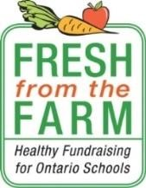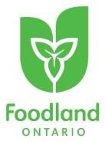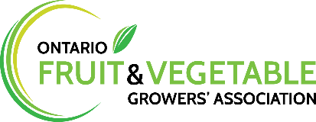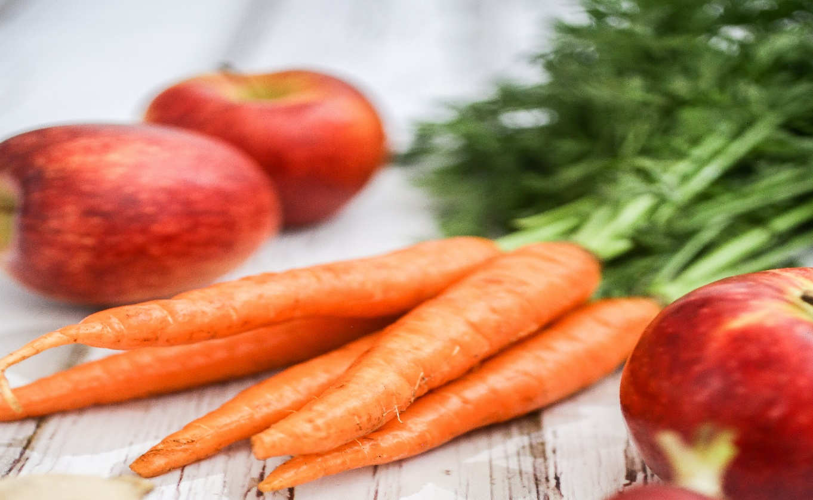

**Vegetable Bundle: $14.00**

**Includes:**

* **3lb bag sweet potatoes**
* **3lb bag carrots**
* **3lb bag yellow onions**
* **5lb bag potatoes**

**Apple Bundle: $15.00**

* **8lb bag of Empire apples**